Indexing Table

The Indexing Table is controlled with User Defined Events.

Right click on an operation or program in the Program view of the ONT and select Object → Start Post

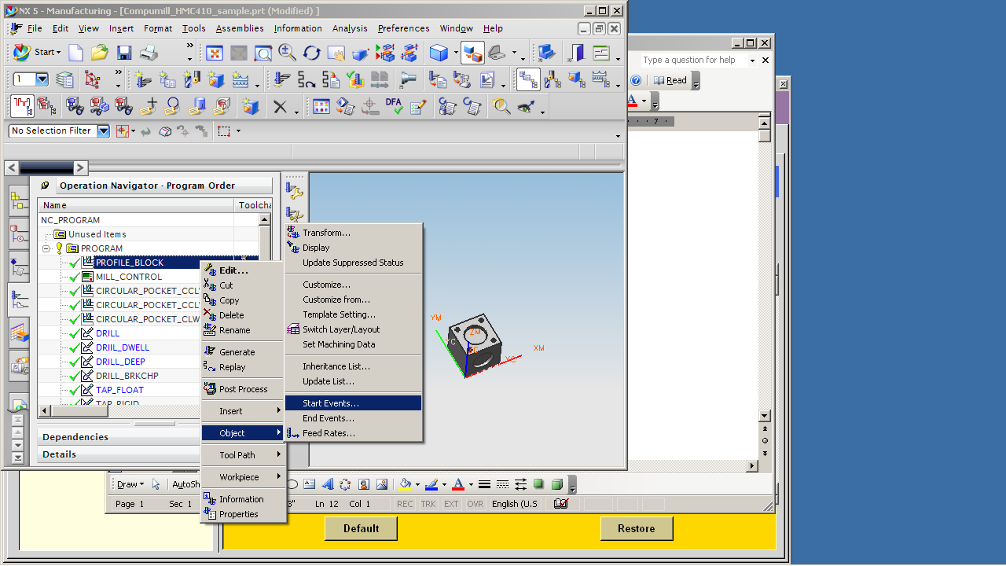

Then select User Defined.

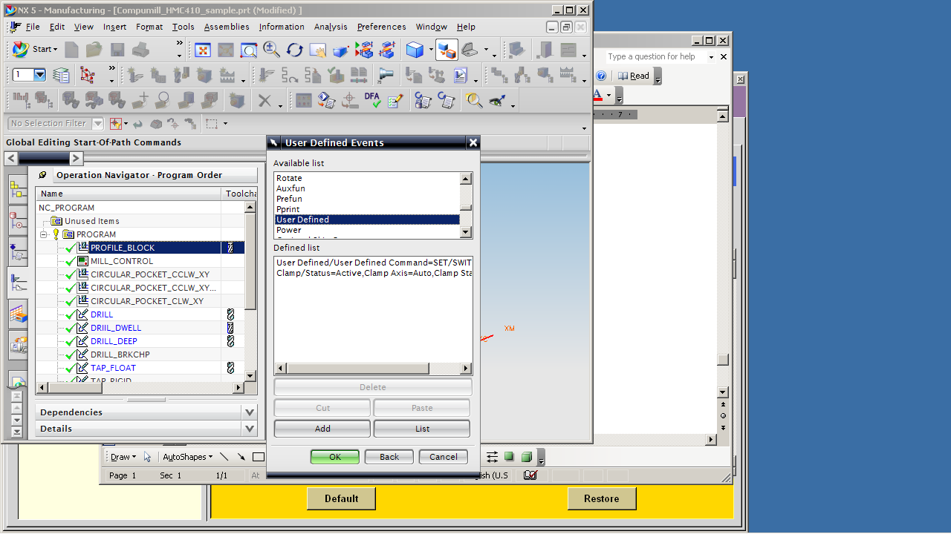

Then enter the commands.

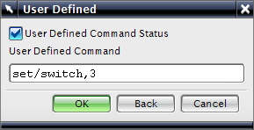

SET/SWITCH,n Will cause indeces to stop #n. Post will remember current stop and index only the number of times to index to the stop.
SET/STOPS,n Defines the total number of stop positions. Default is 8.
SET/INDEX,m Defines the M code to cause one index. Default is M20.

